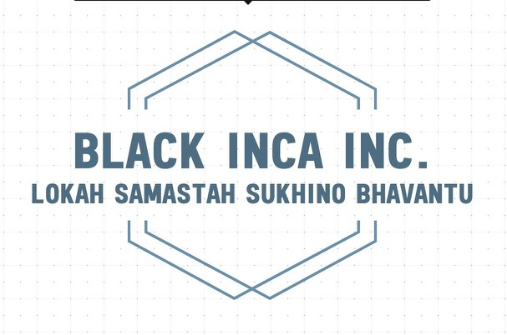

**Market GO**

# PopcornSwirl IOS App

# Technical requirement document

**Version 1.0**

Ahmad Murad

Lead Developer

Black Inca Pvt Ltd.

123 XYZ

Street London, ST 12345

**Table Of Contents**

PopcornSwirl IOS App 0

Technical requirement document 0

1- Versions 2

2- Introduction 3

2.1 Document Purpose 3

2.2 Client Needs 3

2.2.1 Context 3

2.2.2 Stakes and Objectives 3

3- General Description of Solution 4

3.1 Operating Principles 4

3.2 General Use Case 4

4- Workflows 5

5- Software design 7

5.1- General Principles 7

5.2- Source Structure 7

6- Application Design 8

6.1- Initial Screen 8

6.2- Detail Screen 9

6.3- Action plan and app components 10

# 1- Versions

|  |  |  |  |
| --- | --- | --- | --- |
| Author | Date | Description | Version |
| Ahmad Murad | 03/01/2020 | Creation of document | 1.0 |

# 2- Introduction

## 2.1 Document Purpose

The present document makes up the functional requirements document for the Popcorn Swirl application. it provides detailed information on how the system solution will function and the requested behaviour.

## 2.2 Client Needs

### 2.2.1 Context

Market GO is looking for a way to market various products to movie lovers.

### 2.2.2 Stakes and Objectives

Market GO is looking for a way to market various products to movie lovers.

# 3- General Description of Solution

## 3.1 Operating Principles

* User can bookmark a movie to form a personal list
* If anything gets a user’s attention, they are redirected to the purchasing resource.
* Mark films as watched and add a note if desired
* View bookmarked list or watched movies lists
* While a user is viewing a movie category listing or details of a particular movie, they are presented with related products that may interest them

## 3.2 General Use Case

* Customer opens app on their phone to view the latest movies list by defaults
* Customer can choose a particular year to view movies that were released in that year
* Customer presses on any movie to see more details
* App shows related advertisements
* If anything gets a Customer’s attention, App redirects Customer to the purchasing resource.
* Customer can add movies to own personal favourite list or add to Watched list with an option to attach a note to the watched movie.

# 4- Workflows



|  |  |  |
| --- | --- | --- |
| Step | Diagram Reference | Requirements |
| 1 | Main Interface | First screen shows a list of films from the current year |
| 2 | See a list of Movies for the current year | Each movie will show title and genre. Customer can pick a particular release year. |
| 3 | View Favourite movie list | List of movies that customer bookmarked as favourite |
| 4 | View Watched movie list | List of movies that customer bookmarked as Watched. |
| 5 | Details of individual movie | Clicking on the movie on any aforementioned screens will bring the customer to a screen showing more details of that movie and watched comments |
| 5.1 | Bookmark or add to watch list | Customer can press a button to add movie to Favourite or to Watched list, and will have the option to add a note to movie marked as watched. |
| 5.2 | Movie purchasing resource | Customer can press on a button to go to the purchasing resource of the movie |
| 5.3 | Related advertisement | Customer will see options of advertisers who offer products related to the movie |

# 5- Software design

## 5.1- General Principles

Project sources and versions are managed by Git.  
The application will be designed in Swift using XCode version 10 for iOS version 12. For both iPhone and iPad.

## 5.2- Source Structure

The logic for the structure of the project directories is as follows:

- the source directories are created so as to respect the MVVM design pattern to ensure good coding practices and standards.

# 6- Application Design

## 6.1- Initial Screen

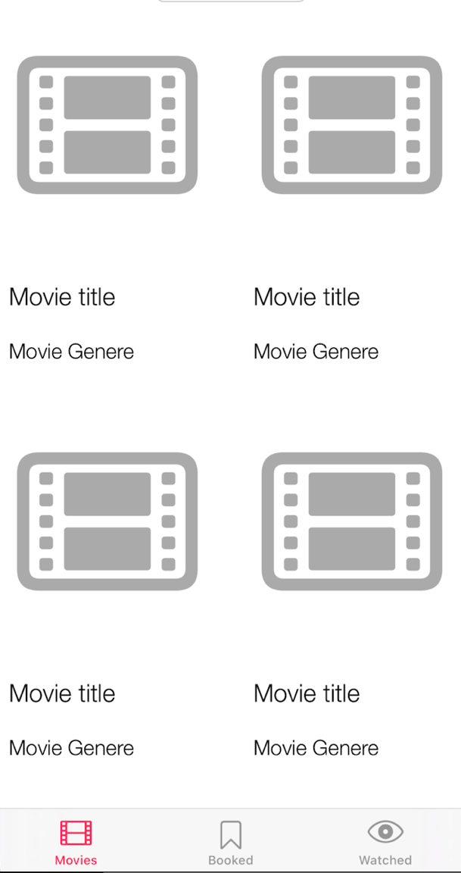

## 6.2- Detail Screen

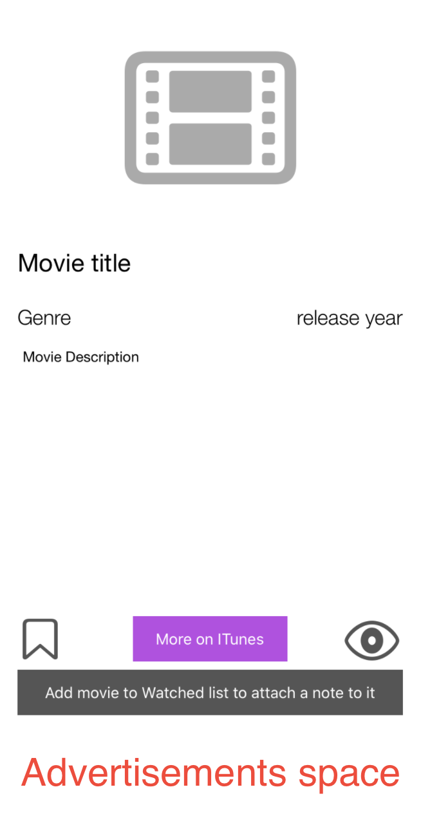

## 6.3- Action plan and app components

* iTunes.apple.com will be used as a movies database
* CoreData as a storage library for bookmarked and watched movies
* TabBarController will be used to make 3 screens quickly accessible for the user.